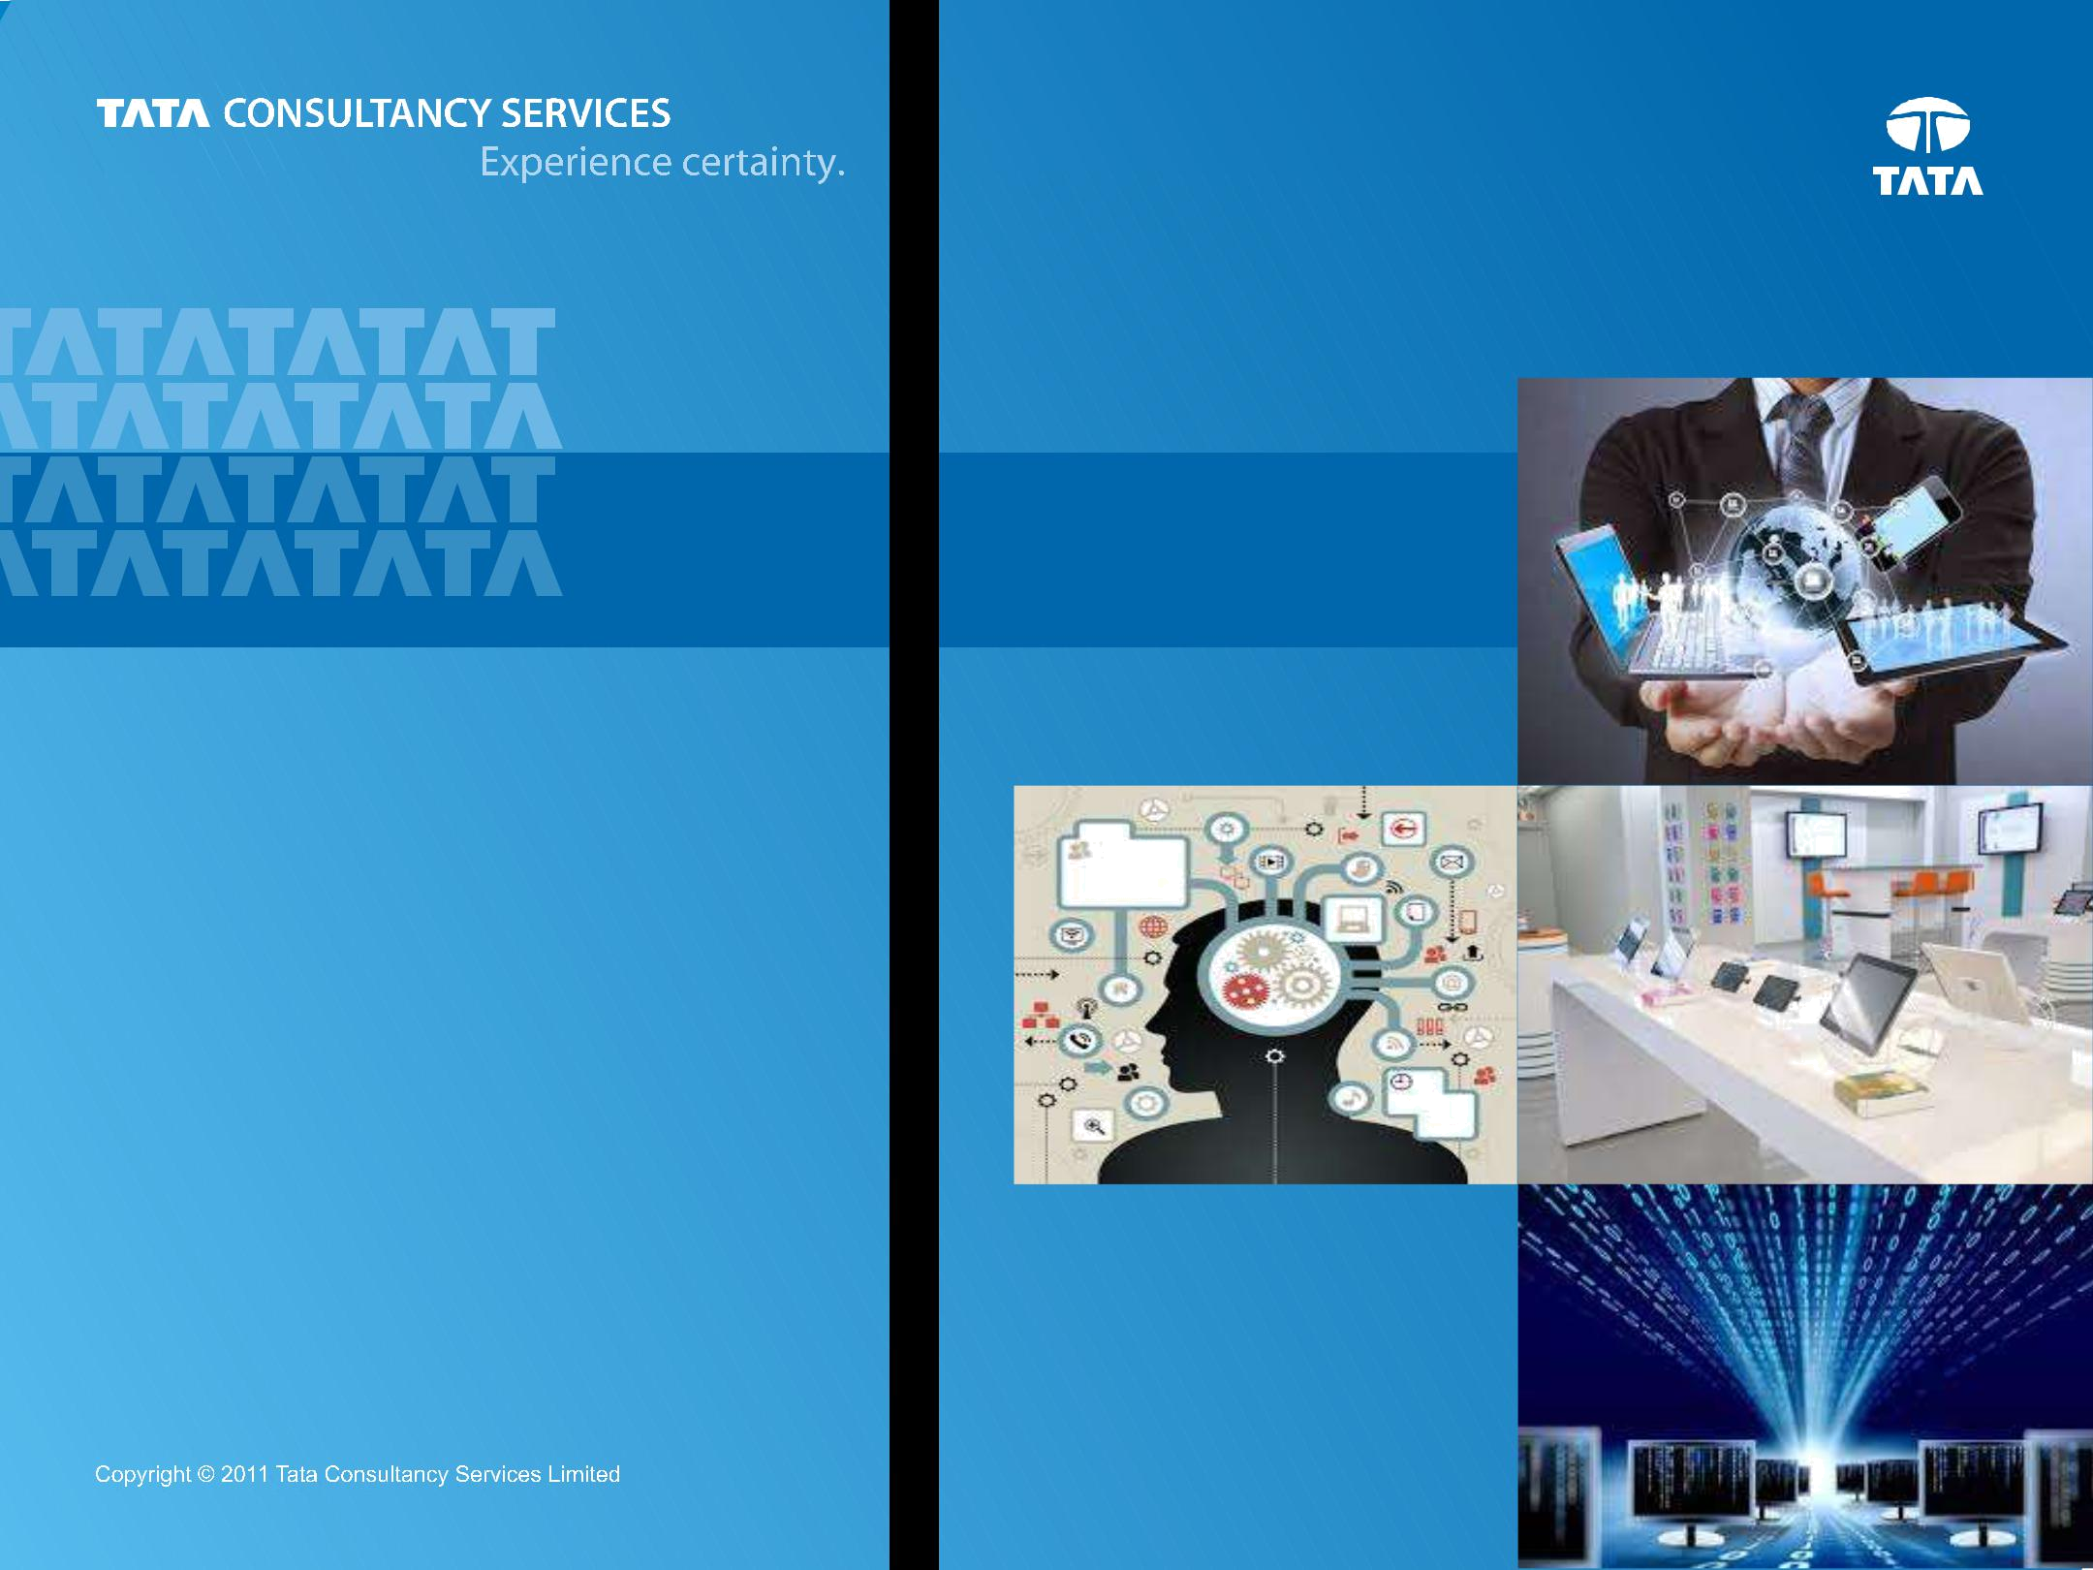

Bank’s view of itself

Customer’s View of Bank
Digital Banking

Chapter 5 : Effects on Retail LOBs

Prepared : October, 2014

1

Content


Introduction

Customer

Digital Banking

Channel Transformation

Effects on Retail LoBs

2


Consumer Lending
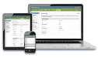


Digitization

Themes

Origination on the Go e Delivery & Signature e Notifications Document Management
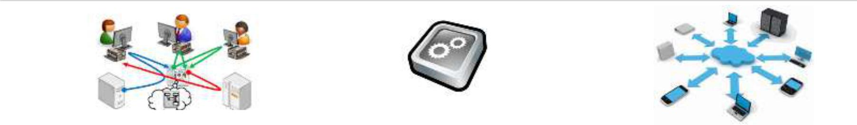

Foundational

Themes

Workflow Rules Common Origination

Sample Journey

- Secure Message (with preview) in mail accessible via 2FA

- Dashboard with missed payment / invoice, cash flow forecast, finance options (OD/Loan), appointment, chat/call/query, FAQs, Summary of previous interactions, scenario calculators, peer actions

- Screen share (and screen capture to capture conversation) with Relationship Manager with video chat

- Action needed (with ETC) box for prior application / conversation

- Application progress tracker with contextual mouse over help, progress & document details

- Follow up information sending options (camera, email)

- Phase wise ETC, duration taken to complete, financial offer calculations, appointment for clarifications (interaction mode, location, reminder)

- T&C, Signature, Reminder for next in workflow
- Account Summary

3

Consumer Lending … additional observations
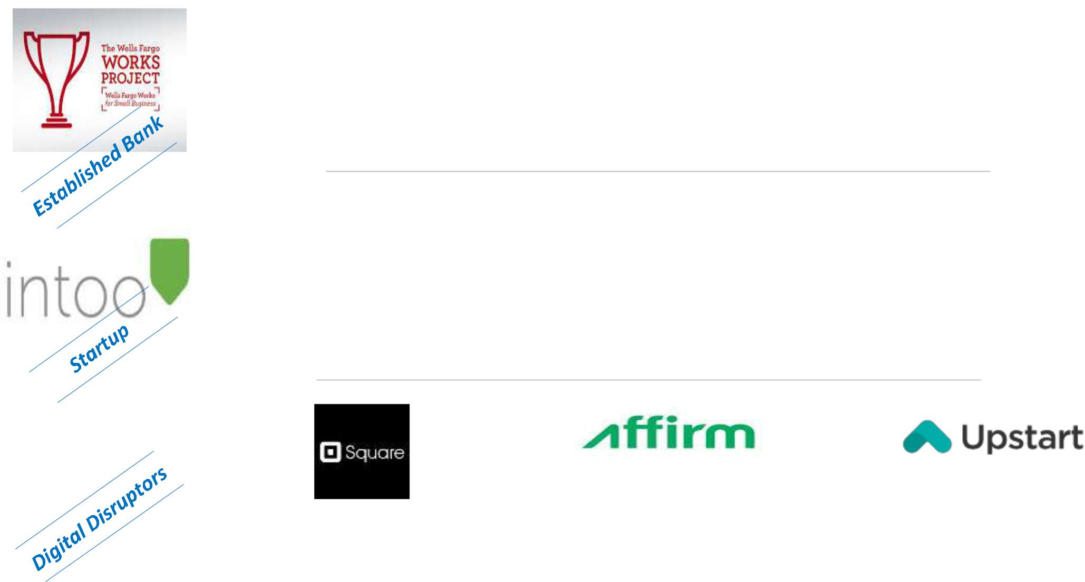

Video content on starting, running, growing a business including preparing for a client meeting

Provides information on small businesses to potential lenders; marketplace solving inefficiency

Merchant cash advance (Square Capital) with repayment based on sales ; no apparent fixed repayment period

Customized Business Cards from the site with business logo; site optimized for a Mobile view

Scours public and private databases, collecting any information attached to the tax ID number providing hard to get cheaper intelligence to banks

Providing customers with instant lines of credit, with risk being gauged from information available in social media profiles

Business checking accounts up by 5.2 % over last year, 98K unique visitors last May and 94K in last June

Revenue Model = Fee from Banks post completion of transaction & listing fee from SMEs

Uses job histories, grades, alma mater, area of study (other than Social Media info) to assess credibility

4

Mortgage (Functional View)

Key imperatives across Lead Management, Origination & Servicing include : Mobile-Social-Omni channel interaction layer + Glued by B2B/C integration & BPM enabled Omni channel + Supported by Customer MDM and Analytics (Customer & Market)
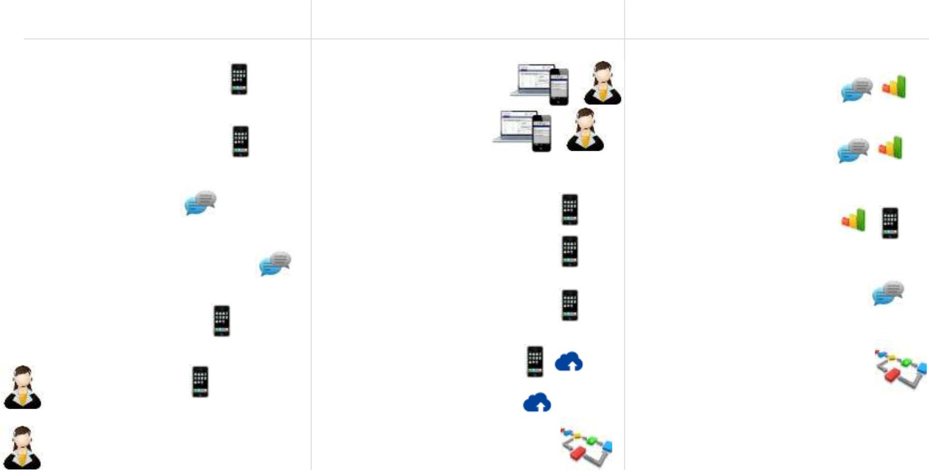

Lead Management

Origination Servicing

Appraisal Enablement

Property Search (AR)

Property Blogs

Neighborhood Community

Good Faith Estimate

Connect to Bank

Financial Advice from Bank

Application Initiation

Channel Continuity

Rule based auto decisioning

Drop Box, Disclosures

eConsent, eSignature

Actionable Notifications

Mobile Docs

PaaS for Imaging

Dynamic Case Management

Retention Strategy

Early Warning System

Financial Planning

Financial Responsibility

Dynamic Case Management

Insurance, Maintenance

5

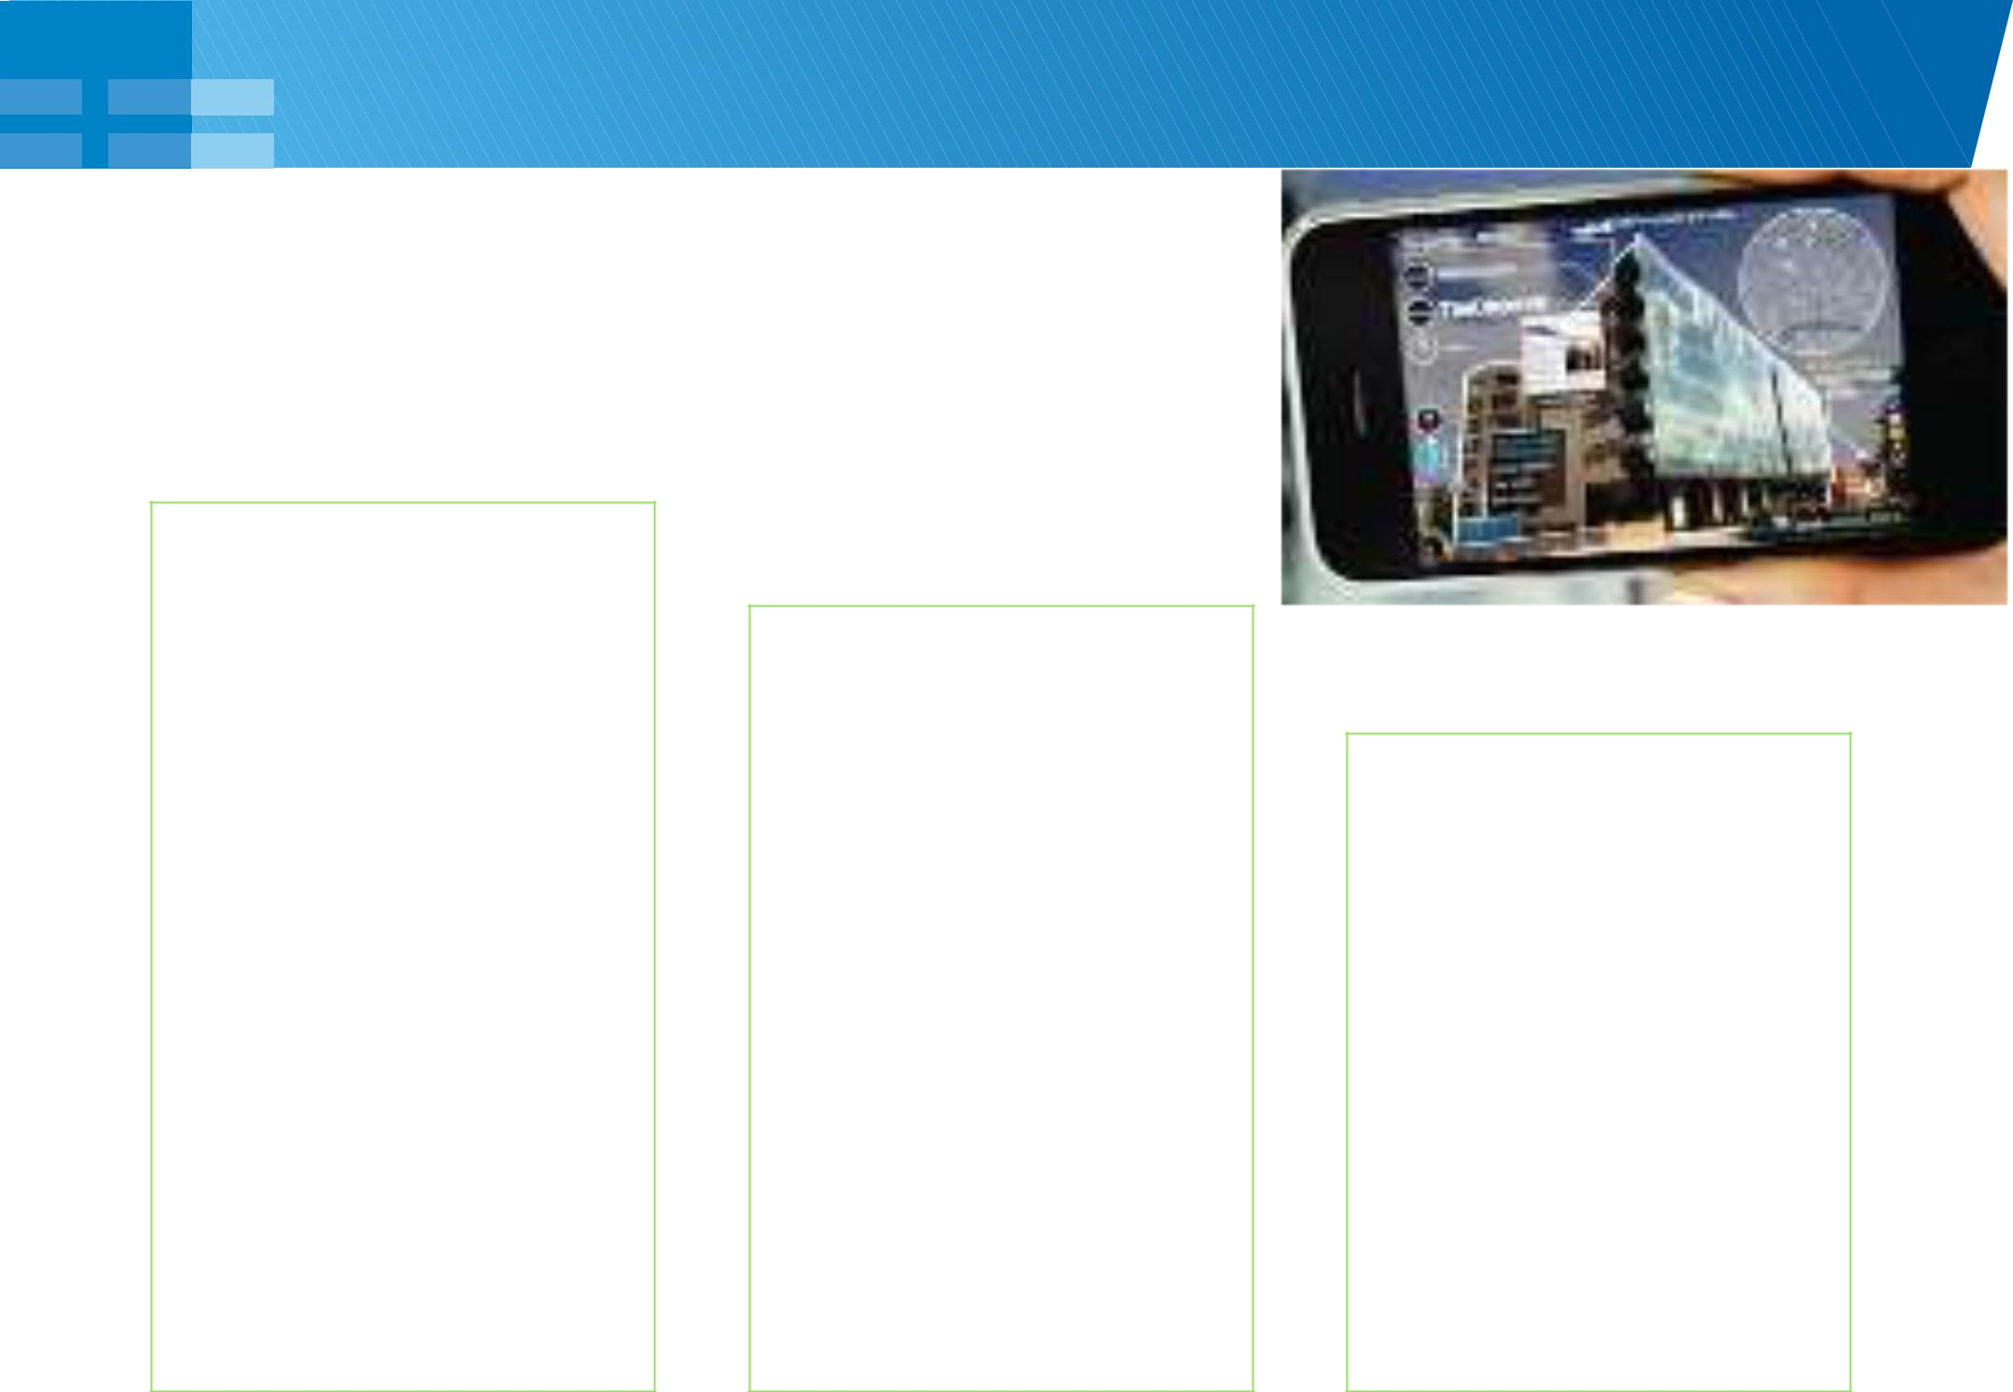
Mortgage (Systemic View)

Mobile

- Appraisal & Online pre qualification for Field Officer (property snaps, GPS enabled borrower & realtor location)

- Property Search (price range, map, configuration, comparisons, real time connect via click to chat/call, pre approval / application initiation)

- Augmented Reality for pre approved properties

- Comprehensive GFE calculator and Bank advice on financing

- Drop Box, Disclosure, e-Consent, Notifications

Utilities

- Channel continuum for application processing
- Mobile Docs

- PaaS for Imaging & Document Management

- Automated rule based offer management, loan decision, loan monitoring

- Early Warning system leveraging Enterprise and Credit Bureau data

- Dynamic Case Management enabling anytime anywhere initiation, approval and modification

Social

- Property Blogs

- Proximity to essentials (clinic, school, mall)

- Neighborhood social community peer interaction

- Analytics for customer retention and Early Warning triggers
- Bank hosted or supported

3rd party blogs on Financial Planning & Responsibility

6

Financial Inclusion

Here, the Segment Category = Unbanked + Under served + Unhappily Banked

Mobile Networks

Mobile Talk time Top Up, Load Cash, P2P, Pay Bill, Commerce, Donations (Charity, Political Parties)

India, Africa

Alternate Lending

From entities like Square Capital against invoice, not fixed monthly installments

Retailer, Utility Firms

Micro Lending and Micro Insurance based on transaction, utility payment history

Latin America

Intimate Banking

Co Operative society with financial agents doing banking (OAO, deposits, payments) over mobile

Cross Border Remittance

Money Transfer at Retail

Store to avoid high cost

of Western Union

Latin America

Prepaid Solutions

Serve and Blue Bird from American Express and Money Card from Green Dot

USA India USA

7

Mobile Payment Instruments

Mobile at POS

It is about paying in store with mobile device with

‘Tap & Go’ or NFC or BLE any other communication protocol
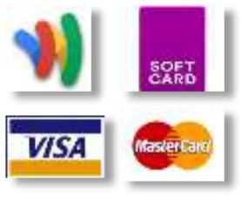

Mobile as the POS

Merchant using Mobile Devices for cards payments


Mobile Payment

Platform

This enables P2P, Merchant payments in both POS/Online


Direct Carrier Billing

Closed Loop Mobile

Payments

Store Cards on mobile;
MNO driven model of
operating within a
topping up and usage
defined ecosystem
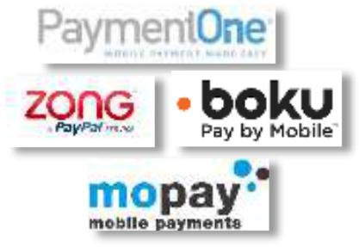


8

Mobile Payment Happenings

High

ROI Potential

Low

 |  | Mobile Top-up | Targeted Offers
 |  |  |  | Benefits Payment
 |  |  | Location Based Payments
 |  | P2P Payments
 |  |  | Mobile Photo Bill Pay
 |  |  | Actionable Alerts | B2B Payments
 |  |  | Actionable Alerts | Biometrics
 |  | Consumer Mobile Wallet |  | Social Payments
 |  |  | Wearable Devices | Social Payments
 |  |  | Proximity / QR Payments
 |  |  |  | Corporate Mobile Wallet
 | Advanced Security
 |  |  | Card less ATM withdrawal
 |  |  | Geo-fencing | Lane Specific Tokens
 | Market Ready |  | Technology State | In Development
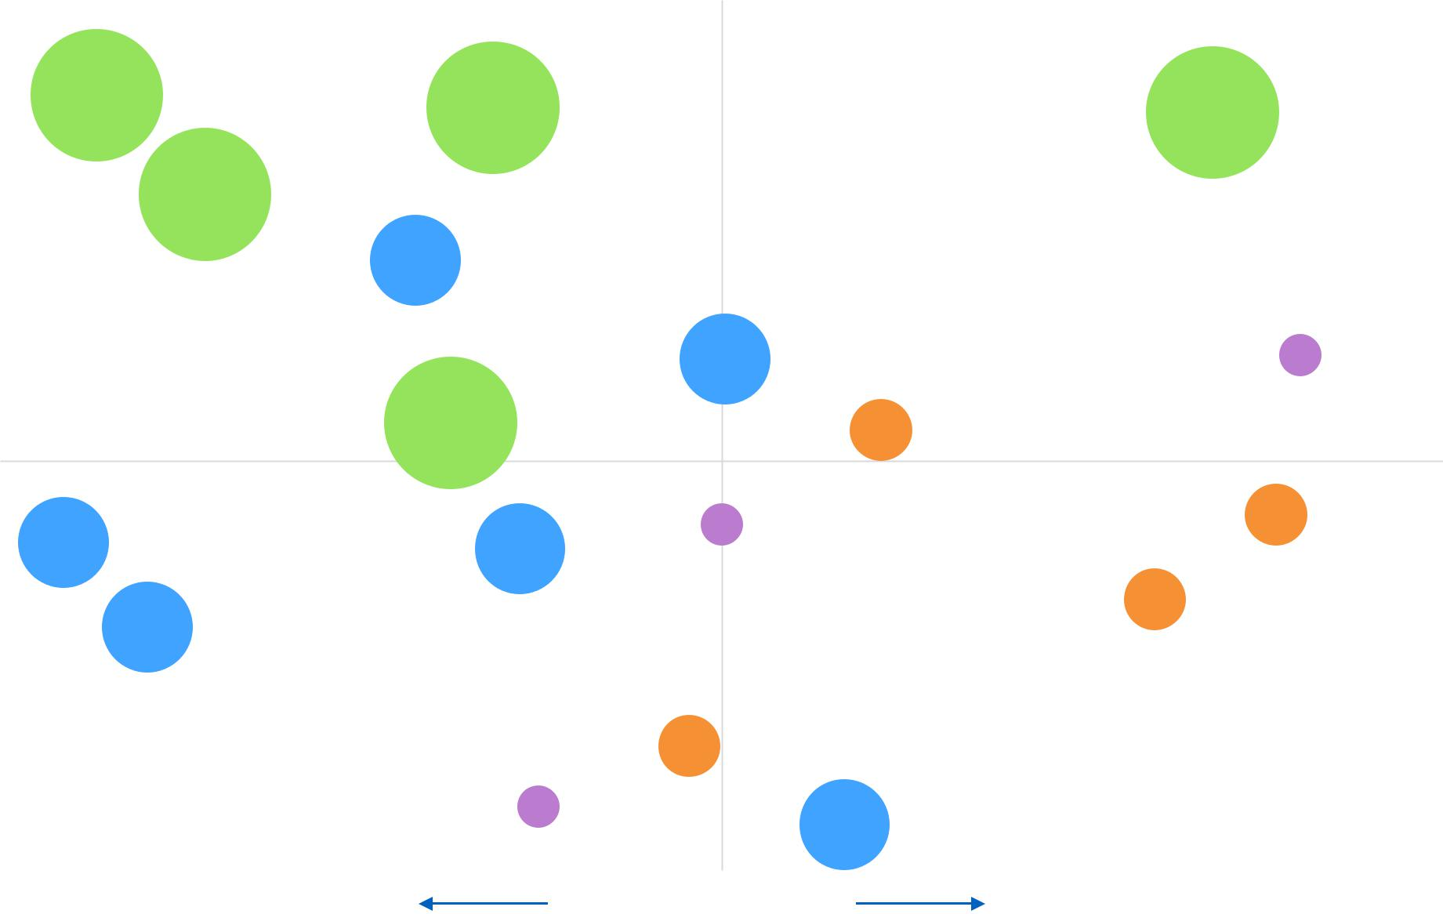

9
Source : CEB Tower 2014

Popular Digital Wallets


Common Functions offered:

Balance check, Txn history, In-store and Online payments, 1-3 clicks checkout, Offers, Alerts, Allow major credit and debit cards, APIs and SDKs for easy partner integration, Security of payment credentials through tokenization / secure cloud, Fraud checks through device and IP data

 |  | Open for all cards, |  | Google Wallet Card, |  | Auto Pay when checked |  | Location Based
 |  | Works in Store & |  | Google Wallet Card, |  | Auto Pay when checked |  | Services, Large
 |  | Works in Store & |  | P2P using email ID, |  | in, MRDC to fund |  | Services, Large
 |  | Online, |  | P2P using email ID, |  | in, MRDC to fund |  | Ecosystem of Players,
 |  | Online, |  | Tracks Online |  | wallet, P2P Payment, |  | Ecosystem of Players,
 |  | Provides Developer |  | Tracks Online |  | wallet, P2P Payment, |  | Model success in
 |  | Provides Developer |  | Purchases |  | Order Ahead |  | Model success in
 |  | Sandbox |  | Purchases |  | Order Ahead |  | Financial Inclusion
 |  | No Bill Payments, No |  | No Merchant specific |  | No Scheduled |  | Primary funding source
 |  | Recurring Payments, |  | rewards, Bonus |  | Payments, Service |  | Primary funding source
 |  | Recurring Payments, |  | rewards, Bonus |  | Payments, Service |  | is limited, Dependent
 |  | Complete card data |  | rewards from Financial |  | problems for Financial |  | is limited, Dependent
 |  | Complete card data |  | rewards from Financial |  | problems for Financial |  | on Mobile Carriers
 |  | sent |  | Institutions |  | Institute customers |  | on Mobile Carriers
 |  |  |  |  |  |  | 10

Digital Commerce Ecosystem
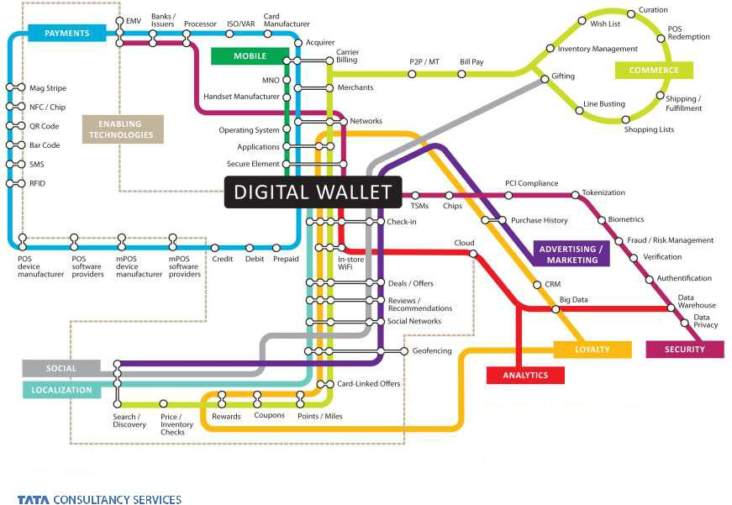

11
Source : PYMNTS.com

Apple Pay : Overview

A device based Digital Wallet with NFC implementation, Issuer side Tokenization, Network supported TSP without needing to store PAN details on the device, involvement of any MNO/TSM and visibility into transaction details for monetization.

How it Works
Provisioning: Take picture → Send to TSP → Get DAN from TSP → Store in Passbook

Merchant Readiness: EMV Contactless for in store; Implement Apple Pay using PassKit framework for in App

In Store Txn: Proximity hold with Touch ID → Dynamic Secure Code & Txn Cryptogram → TSP translation → Issuer for Auth

In App Txn: Check for device with SE & Payment instruments provisioned therein → Payment Token from PassKit → Processor SDK APIs called by app

Observations

- Safer CNP ; possible review of pricing around ‘mobile present’ paradigm

- Commercial & Liability Models to evolve in US and Abroad ; MNO and TSM models hammered

- International Expansion: A few positives (EMV Contactless, Consumer familiarity) and a few hurdles (71 % Android, Device Ownership)

- Amazon, Braintree to remain a formidable competitor; PayPal did not participate
- Absentees : PayPal, Walmart, BestBuy

- iBeacon (P2P) and iPad Touch ID could be next

12

Apple Pay : Implications on Ecosystem

Consumers

Merchants

(In Store)

Merchants

(In App)

Issuers

Networks

Easy to set up & cool to use, No fees, Familiar payment instrument

Based on EMVCo contactless standards, Possible PCI relief, Customer transaction data ownership

Simplified check out & reduction in basket abandonment, Reduced Fraud (biometrics + tokenization), Higher spend velocity

Reduced fraud rates (without interchange changes), Txn & Interchange volume (in lieu of cash), Access to customer txn data

Cards centric models, Higher Txn volume, TSP role & revenue, In Store Brand visibility

Consumer Reach, Limited Acceptance, No value added services (yet), Niggling Security concerns (iCloud hacking), No P2P / Bill Pay

System changes, Debit volume moving to Credit, Debit Txn routing choices unclear, MCX

Liability ownership unclear, system changes to integrate Apple Pay into the App

Transaction fees, Investment into tokenization, Brand in the shadow, Credential inaccessible from bank app, No direct control on instrument choice

No brand visibility for in app purchases, possible future impact on Network digital wallets

13

Summarizing 2014 Trends in Digital Payments

This space is witnessing polymorphism enabled by diverse forces : Wearables (Glass, Watch, Ring), Modes (BLE, iBeacon, QR Code), Technologies (Biometrics, In App, Host Card Emulation)


1

NFC’s global survival will continue to be challenged (local success in China, South Korea)


4

Amazon to offer retail solutions for payments, customer insights


7

Square will see slower growth in spite of Square Capital and Square Market

2

BLE will conquer Retail with usage in Payments, P2P fund transfer, notifications & offers in store


5

Digital Payment industry might consolidate with targets being Stripe, Dwolla, LevelUp etc.


8

Mobile Wallets to face convenience parity unless it takes ‘passbook’ form

3

Bitcoin itself might be controversial but the concept of a global exchange will gain traction

6

Carrier Billing will continue to dominate emerging markets


9

Retail Banking apps to be all in one multi device payments and finance platform

14

Data might be the ‘D’ in Digital

We are living in the world of digital trace where we or somebody can collect, analyze and

Intelligence agencies of any

country can combine data/information from social media, CCTV cameras, phone calls and messages to track down criminals and predict the next criminal activity or terrorist attack

Facebook using targeted advertising based on analyzing information of FB profile and activity-hobbies, age, location, relationship status, like, area of interest, favorites (movies, songs)

explore.


Political parties can use social | Insurance Companies can use
media sentiment & analytics to | GPS information to analyze how fast
determine where they need to focus | we are moving and can provide real
while Companies can analyze FB & | time and live traffic up-dates ; now
Twitter posts to determine & predict | the same could be augmented by
marketing campaigns, sales pitch | Apple’s new Barometer sensor


Album Companies can use the | Google driverless car is
web log files and data to determine | another project by Google where
the listening preferences and | they are analyzing a colossal volume
sequences and predict the most | of data from sensors and cameras in
popular song/track in that particular | real time to stay on the road safely
area for next live shows and events

Hence, “Search” is key


Page Rank Social Graph Graph API Graph Search

15

Big Data : Analytics & Insights

Solution looking for problem; current usage paradigms = Do More + Do Faster + Do Cheaper


Customer &

Market Insights

• Social Media & Clickstream Analysis • Next Best Action

• Customer Churn & Delinquency • Customer Profitability and life time value

• Enhance Customer Segmentation • Data Monetization & Merchant Analytics


Risk & Fraud

Insights

• | Financial Risk Analysis | • AML & Fraud Investigation
• Market & Portfolio Risk Analysis |  | • | Real-time Fraud Detection
• | Lending Risk Assessment (SME or | • | Market Surveillance
 | Institutions) | • | Warm Data Archival


Operational

Insights &

Optimization

• High Volume ETL offload |  | • | System Log Analytics
• | Computing Intensive Batch offload | • | System Failure Analysis
• | Storage Cost Optimization | • | Data Integration Hub

Segmentation drives the need for Analytics with Analytics driving more sophisticated segmentation levels ; ultimate goal being ‘segmentation of one’
16

Without being intrusive

Survey Observations across Investment versus Values, Location-Authorization and Location-Purchase

Better response to product |  | Customer Analytics to blend
Better response to product |  | Retail and Wealth divisions |  | Better response from higher
customization based on |  | Retail and Wealth divisions |  | Better response from higher
customization based on |  | with more wealth managers |  | income groups ; neutral
structured data over social |  | with more wealth managers |  | income groups ; neutral
structured data over social |  | offering card, cash |  | impact on education levels
data |  | offering card, cash |  | impact on education levels
data |  | management solutions

Better response with |  | Better response from
messages from the Financial |  | Better response from |  | Better response when
messages from the Financial |  | younger age bracket; US |  | Better response when
Advisor rather than |  | younger age bracket; US |  | message emanates from a
Advisor rather than |  | being more open than UK |  | message emanates from a
contextual messages from |  | being more open than UK |  | Loyalty (“consent”) context
contextual messages from |  | within same age group |  | Loyalty (“consent”) context
system |  | within same age group

Fine line between delighter and creepy feel = Real time responsiveness from Financial Advisor versus Contextual messaging leveraging customer analytics

17


THANK YOU

Prepared : October, 2014

18

